DAY 3 : DATA MIGRATION AND API INTEGERATION

* Creating a migration file to fetch data from an API
* Adding connection for env.local
* Setting up an environment
* Adding mapping to fetch data to display

**MIGRATION CODE**

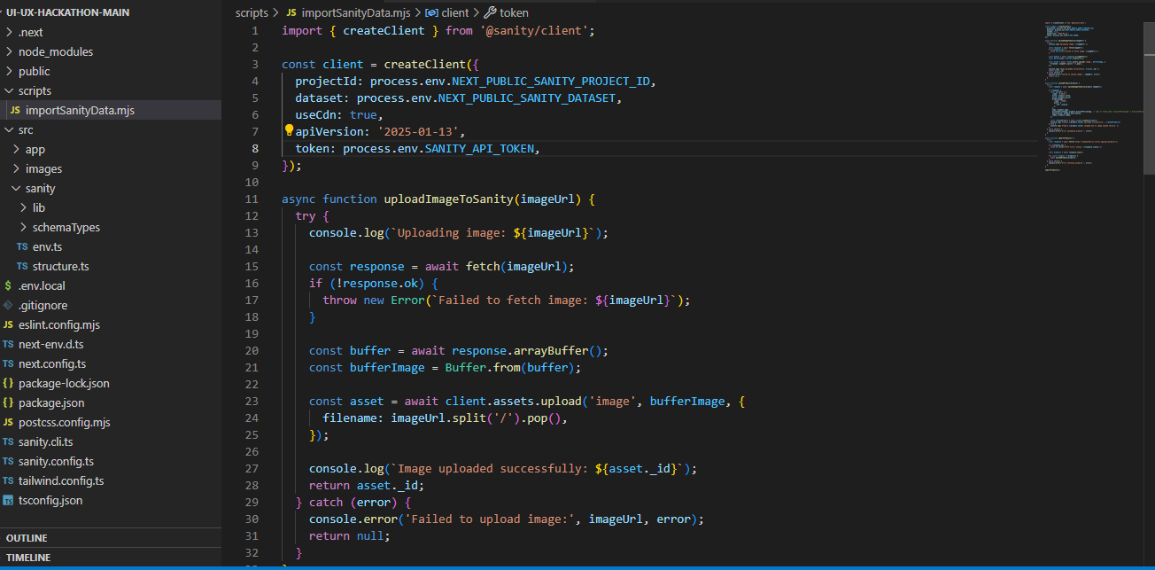

**MAPPING CODE**

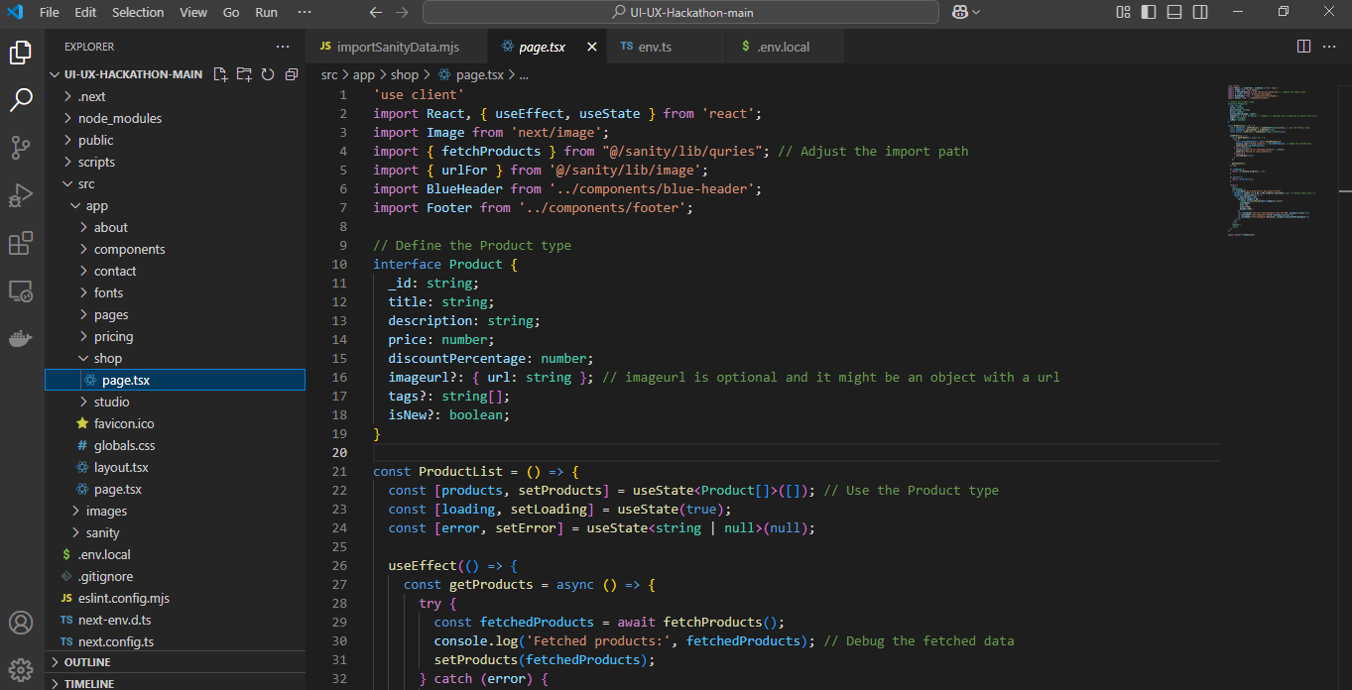

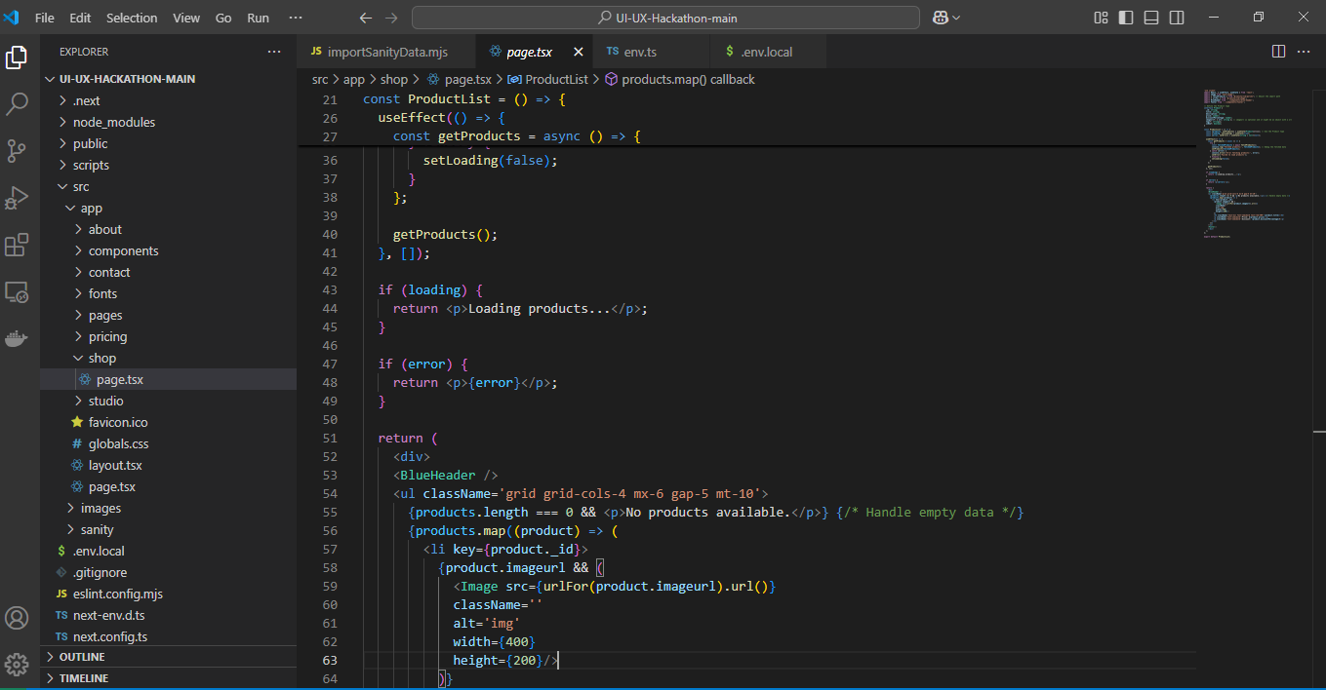

**Result**

